How to Use the Digital RPG Consent Checklist

**How to Use and Share The Checklist**

The Digital RPG Consent Checklist is a google form that you can share with your players, who can fill it out anonymously. Sharing a Blank google form is a little more complicated than sharing a google doc, so I’ve made up this quick guide to using and sharing the form.

[Click Here for a link to an editable copy of the checklist](https://docs.google.com/forms/d/16jQut7tvjt-Rblu_iFqoQC68uA_aRratd4ufq_1wXlk/copy)

The Link above will lead you to a page prompting you to make a copy of the form. From there you can edit it and share it as much as you like, and only you will be able to see the responses.

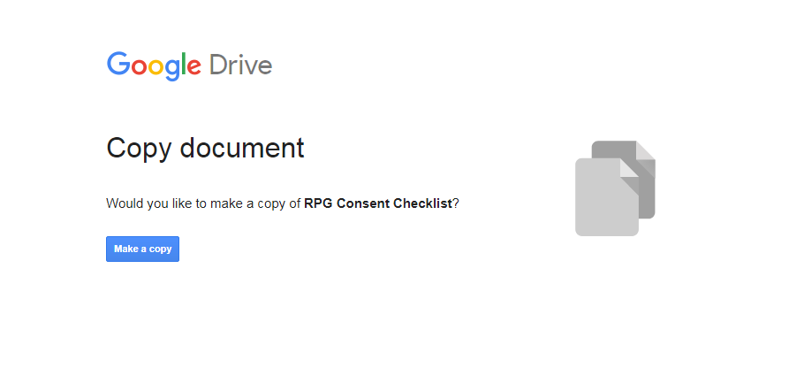

I recommend you keep one “clean” copy saved to your drive and make a new copy for every new campaign do this either from your google drive, or from the form directly by clicking the 3 dots and choosing the make a copy option

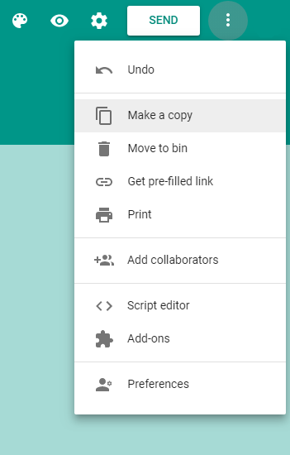

To share it with players, copy the link generated when you click on the send button.

**The Advanced Stuff**

If you are making significant edits to the form and want to share and editable copy of that one. You have to do the following

1. Make a folder in your google drive that is set to view only
2. Move your edited form into that folder
3. Open the form to the edit page, and copy the URL
4. At the Very End change the [/edit] to [/copy]
5. Share the URL with someone who wants a copy of the form.

For example: This is the link to if your link to the form is <https://docs.google.com/forms/d/xxxxxxxxxxxxxxxxxxxxxxxx/edit> (this is not a real link)

Then change it to

[https://docs.google.com/forms/d/xxxxxxxxxxxxxxxxxxxxxxxx/](https://docs.google.com/forms/d/xxxxxxxxxxxxxxxxxxxxxxxx/edit)copy

Now you can share your modified version to your heart’s delight! Happy Consenting!

**Acknowledgements**

**The Digital RPG Consent Checklist** *was created for the* TTRPG Safety Toolkit *and is adapted from the RPG Consent Checklist that appears in the* Consent in Gaming *supplement by Sean K. Reynolds and Shanna Germain, published by Monte Cook Games. It can be found at https://www.montecookgames.com/store/product/consent-in-gaming/*

**The TTRPG Safety Toolkit** *is a resource created by Kienna Shaw and Lauren Bryant-Monk.* The TTRPG Safety Toolkit *is a compilation of safety tools that have been designed by members of the tabletop roleplaying games community for use by players and GMs at the table. You can find it at bit.ly/ttrpgsafetytoolkit.*

**Source for sharing google forms:**<https://www.coffeenancy.com/2019/04/share-a-copy-of-a-google-form/>